**Date : 14-08-2020**

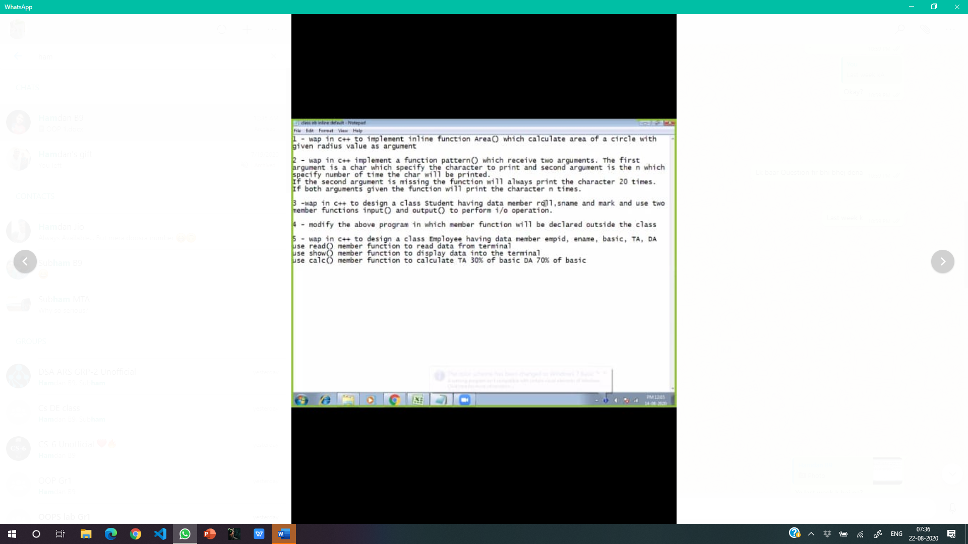

**1.**

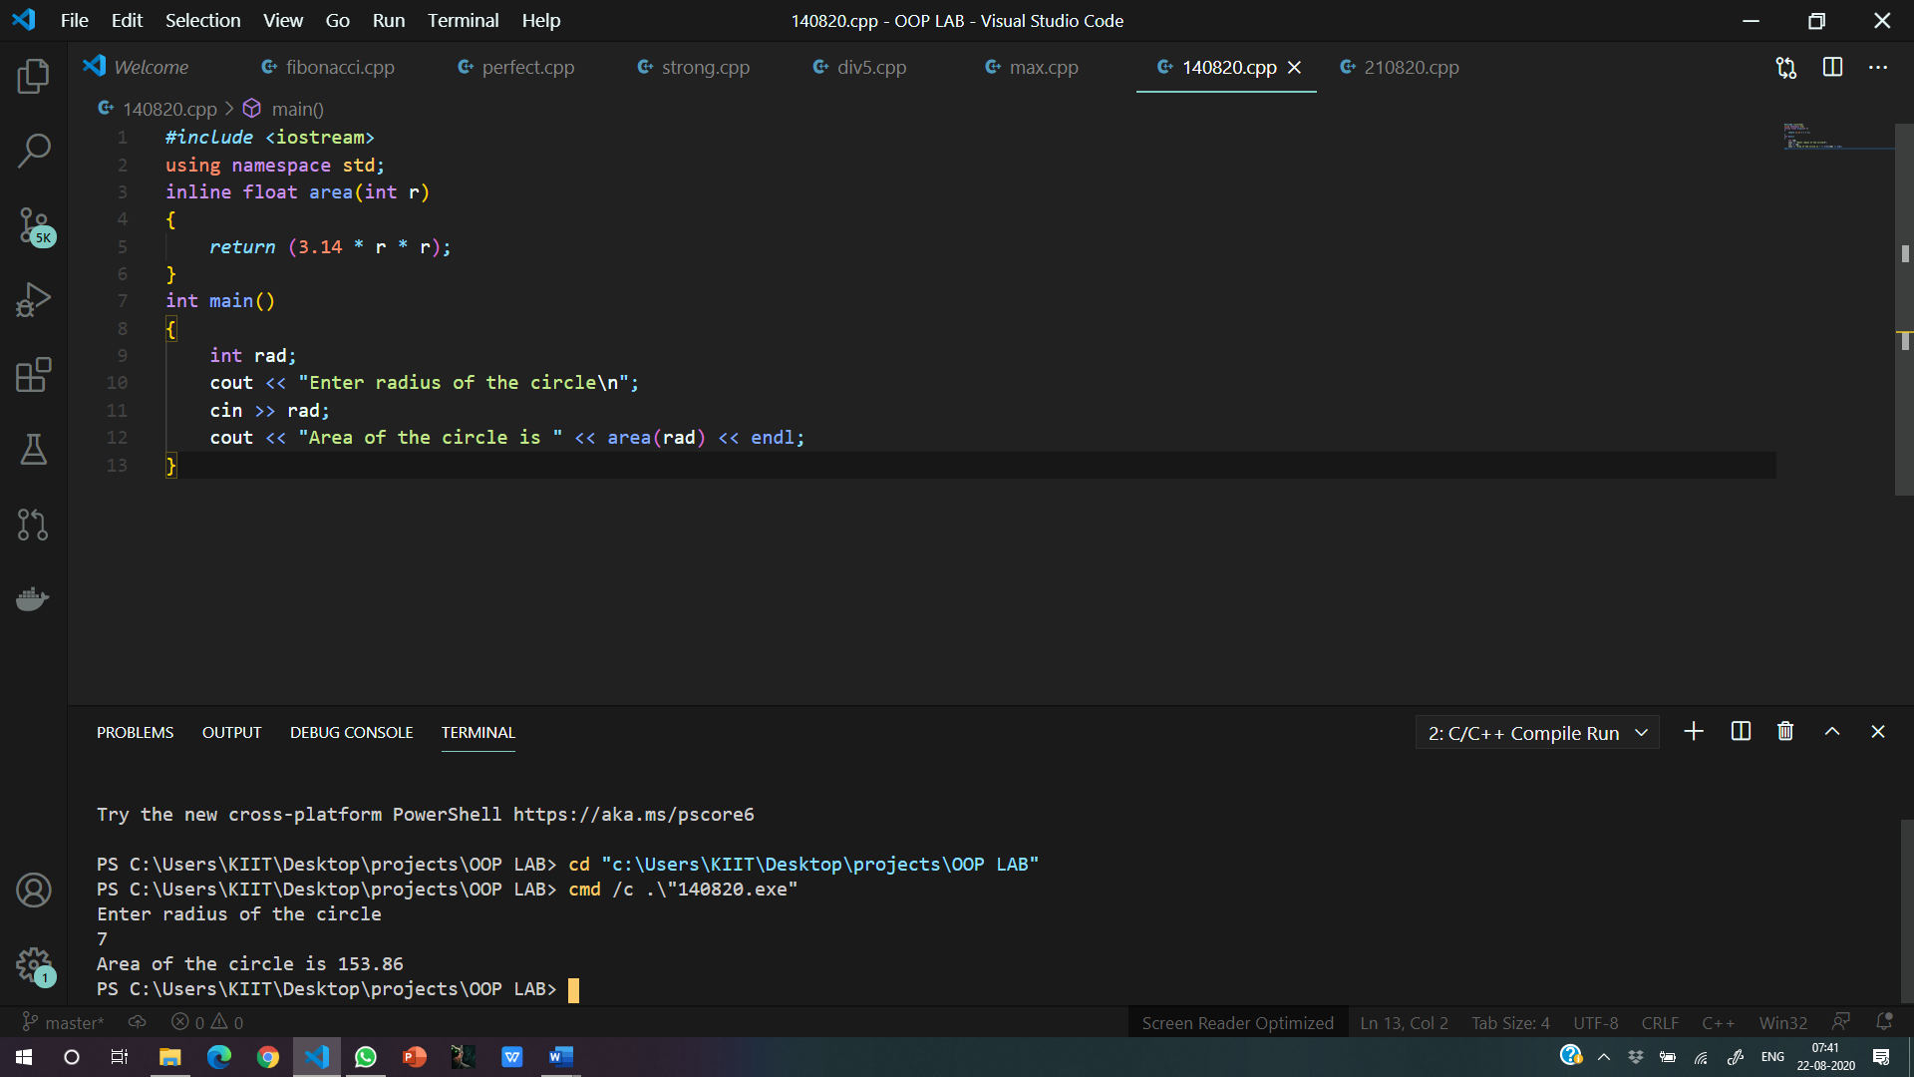

**2.**

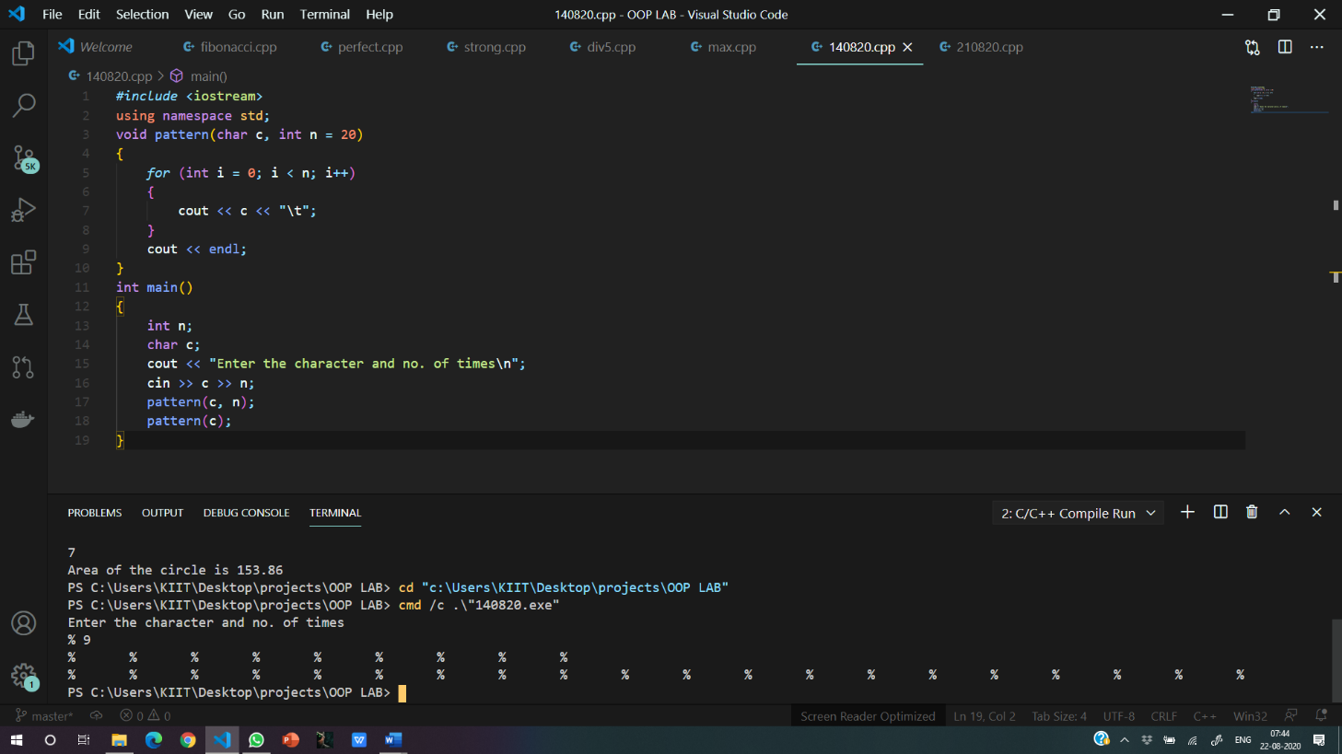

**3.**

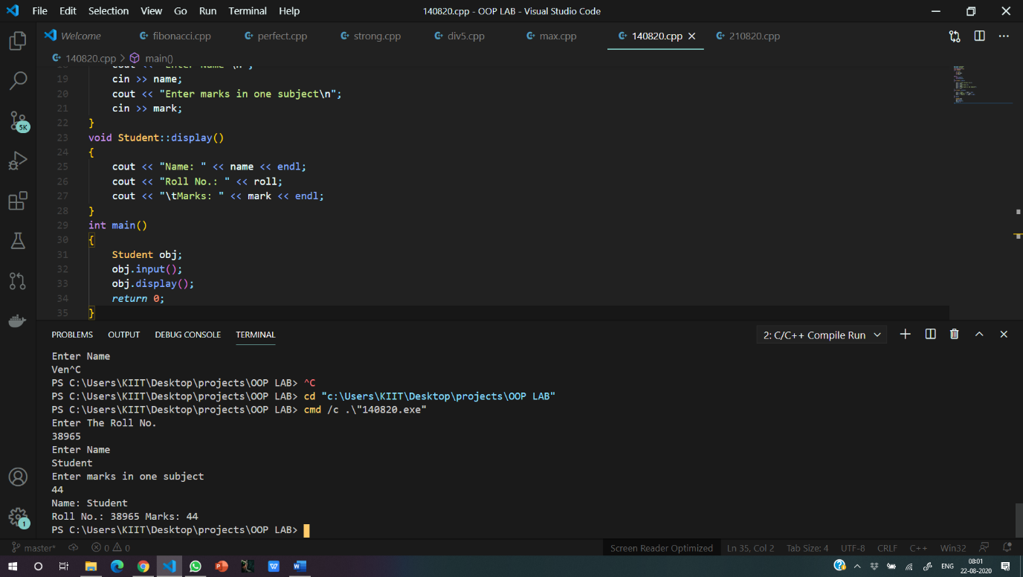

4.



**5.**

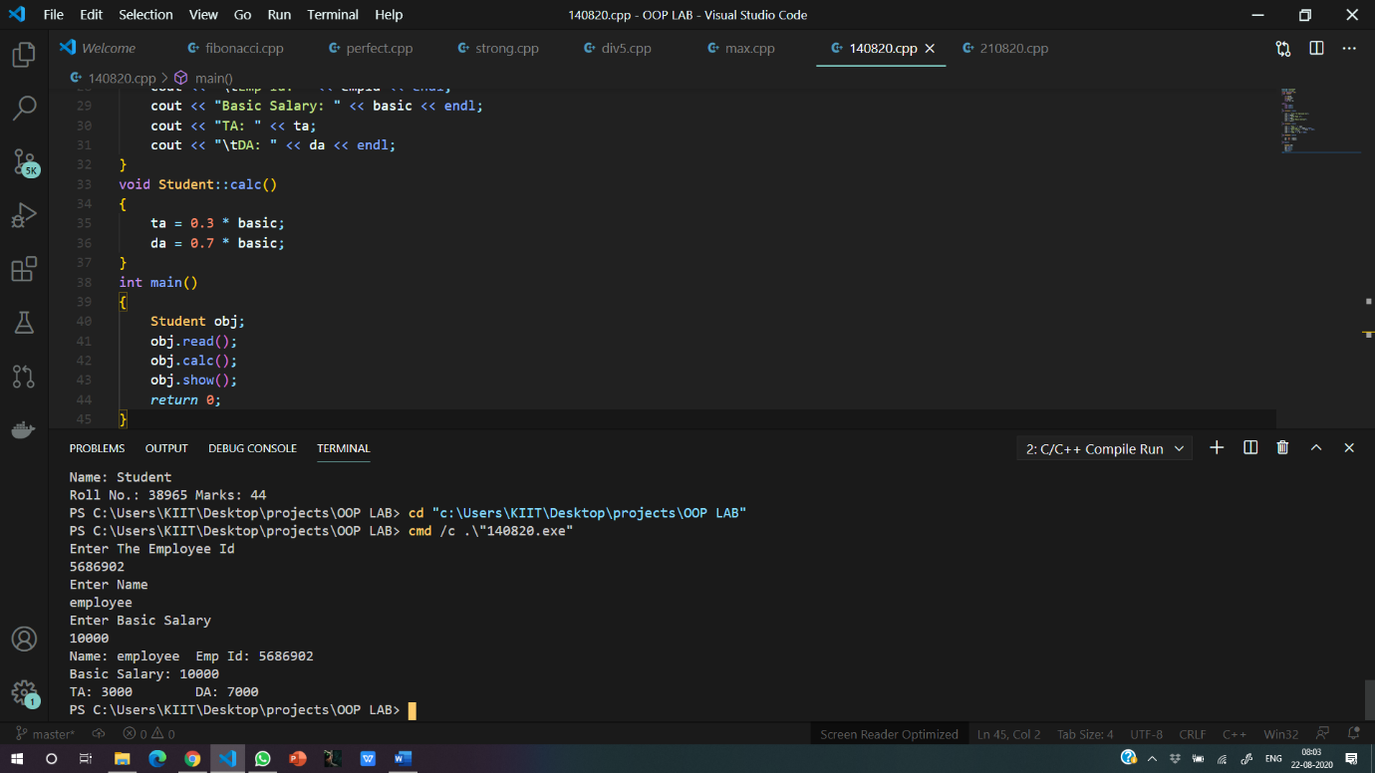

1. WAP to swap private data member of two classes.

[The classes have no relation with each other].

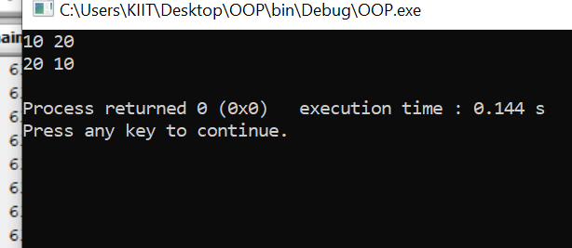

7. Create two classes which stores distance in feet, inches and meter, centimeter format

respectively. Write a function which compares distance in object of these classes and

displays the larger one.

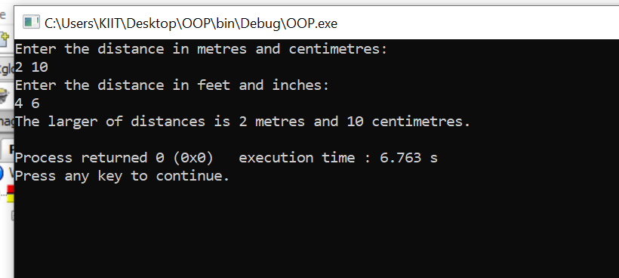

8. Create a class with an integer data member. Include functions for input and output in

class. Count the number of times each function is called and display it.

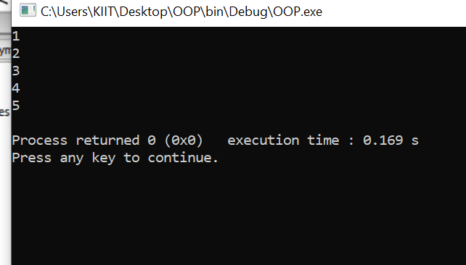

9. Create a class which stores name, roll number and total marks for a student. Input data for

n students. Find the average marks scored by n students, store it as a data member of

the class and display it using a function which may be called without object.

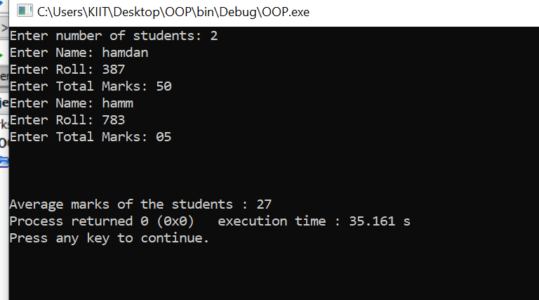

10. Create a class which stores name, author and price of a book. Store information for n

number of books. Display information of all the books in a given price range using

friend function.

